**Making Water Resource Decisions more "Informationally" Efficient: Development of a Geospatial Water Rights Decision Support System for Kittitas County, Washington[1]*[2]***

1. **INTRODUCTION**

This project created an open-access geospatial water rights database for the Kittitas Valley, Washington State[3]. The Kittitas Valley, part of the larger Yakima River Basin (YRB) serves as a pilot project for the integration of physiographic and water resource data in a user-friendly format. The goal was to provide water right holders and potential purchasers of water with parcel-specific data about water rights in the system. While specific focus was placed on the dissemination of water rights data, the creation of the database demonstrates the utility and potential to integrate spatially referenced biophysical data with property rights data. In watersheds in which demands for water exceed available supply, closing the informational asymmetries of water rights by making priority dates and volumetric information more easily available via a web-based mapping application could influence the ways in which current water rights holders use water and how it is reallocated.

1. **ORIGINS**

Geospatial catalogs of water resources are not new. Several catalogs of available water supplies, often referred to as Water Resources Decision Support Systems (WRDSS) have been developed by state entities (Table 1). **Geospatial databases are being created for a multitude of land-management purposes including wildfire and fuels management, and wind generation (Zambelli et. al., 2012; Mari et. al., 2011; Schmidt et al, 2002; Densham, 1991).** These systems vary in their scope, and exist, largely in Geographic Information Systems (GIS) formats that are not useable without proprietary software and specialized knowledge. In other words, most bulk water users, who are often the primary water rights holders, such as housing developers and irrigators lack the technological capabilities to easily access these data.

Table 1: Select Digital Water Rights Information (Adapted from Pease, 2012)

|  |  |  |  |
| --- | --- | --- | --- |
| State | Entity Created/Data Admin | Data Shown (if not displayed on map viewer than downloadable) | Water Rights Homepage URL |
| Arizona | Arizona Department of Water Resources | devices, wells, watershed, groundwater basin/subbasin | <https://gisweb.azwater.gov/waterresourcedata/> |
| California | California Division of Water Rights | Water Rights, points of diversion, watersheds, water bodies/streams, hydrography | <http://www.waterboards.ca.gov/waterrights/water_issues/programs/ewrims/> |
| Colorado | Colorado Division of Water Resources | climate, gages, diversions, well applications, water bodies, land use | <http://water.state.co.us/DataMaps/GISandMaps/AquaMap/Pages/default.aspx> |
| Idaho | Idaho Department of Water Resources | gaging stations, groundwater, regulatory areas, irrigation, public water supply, water rights (places of use and diversion), wells | <http://maps.idwr.idaho.gov/mapall/> |
| Nevada | State of Nevada Division of Water Resources | Hydrology, Point of Diversions, Wells, Basins | <http://water.nv.gov/data/permit/> |
| Oregon | Oregon Water Resources Department | water rights, ground water, water districts, water availability basins, gages | <http://www.oregon.gov/owrd/pages/WR/wris.aspx> |
| South Dakota | South Dakota Department of Environment & Natural Resources | well locations, surface water discharge, stream gages, rivers, lakes, flood zones | <http://denr.sd.gov/des/wr/dbwrsearch.aspx> |
| Utah | Utah Division of Water Rights | points of diversion, dams, irrigated acreage, stream alteration | <http://www.waterrights.utah.gov/wrinfo/query.asp> |
| Washington | WA Department of Ecology | Devices, Application, Certificate, Permit, Claim, Gauging Stations | <http://www.ecy.wa.gov/programs/wr/info/webmap.html> |
| Wyoming | WY State Engineer's Office | Water rights (surface and ground) | <http://seo.state.wy.us/index.aspx> |

Within the context of GIS literature is an immerging recognition of the need to disseminate geospatial information to the public for decision making in a user-friendly format. These types of public GIS systems are often referred to as ‘participatory GIS’ (Mekonnen, 2014; Alagan and Aladuwanka, 2013; Corbett and Keller, 2006). This will allow those with vested interests in water management, such a water rights holder, to access and query information without the need for specialized GIS training (Streeter, 1988).

This project mimics the functionality of existing geospatial catalogs, or WRDSS, and provide these data in an open-access, web-based format which is easy for inexperienced computer users to navigate. It **blended the full-functionality of a WRDSS (multi-scaled maps, simultaneous display of multiple thematic maps, data tables, and data query functions) within a web browser interface to create participatory GIS for water rights decision making. A geospatial database, accessed through a public participation web mapping application, provides stakeholders in the YRB the ability to access spatially-referenced information about water rights, river gages, groundwater data, or data on entire stream reaches. In addition, land-use data can be viewed in conjunction with water-related data to illustrate linkages between water use and rural land-use patterns. Such information could allow for more informed water management decisions.**

1. **YAKIMA RIVER BASIN ADJUDICATION**

**Prior Appropriations water rights are correlative rights, meaning the property rights of one right are a function of the attributes of surrounding rights senior in priority (Matthews, 2003; Gould, 1988). Sound decisions regarding water use are predicated on an understanding of the available supply of water in the basin and the other uses of water within the watershed (Gould, 1988). Without an understanding of how the parameters of one right fit amongst other rights informational asymmetries develop (Pease, 2012; McCormick, 1994), increasing transaction costs (Krutilla, 2010; Pease, 2012). The Yakima River Basin (YRB) located in central Washington State is one of the few major river basins in the western United States that has recently undergone a full water rights adjudication, with a Conditional Final Decree issued in 2007 (**WA Department of Ecology, 2014a**). A water rights adjudication is a process that determines the volumetric extent and temporal priority of all water rights (Ottem, 2006). Adjudications are protracted, expensive legal undertakings, but they provide substantive utility to water managers. When complete, they provide clear data on individual water rights including the rights priority date and the amount of water that can be used. Unfortunately, with the disparate locations in which water is used, data associated with individual rights lacks context—for example the place of use’s proximity to a watercourse or to other water rights (Gould, 1988).**

**The YRB is an advantageous location to test the development of a user-friendly WRDSS because of the completion of the adjudication, and because many irrigators are small scale, and do not have the expertise or skill to access Geographic Information System data files and data layers. Periods of water scarcity are frequent in the Kittitas Valley and the greater YRB. Providing water users web-based access to a database that shows their water rights in relationship to the other rights holders in the valley could assist them in decision making about how to use their water, or help them find additional water supplies when drought means they will not have adequate supplies to meet their needs.**

1. **CREATION OF A GEOSPATIAL DATABASE**

Datasets were obtained from public sources, including the U.S. Bureau of Reclamation, Kittitas Reclamation District, and the Washington State Department of Ecology. These datasets included stream gage information, reservoir levels, land-use data, canal locations, well data, salmon habitat, areas previously used by salmon that are now blocked by human created impediments, and river return flow locations. Because of the issuance of the Conditional Final Decree for the water rights in the basin, it is important to place the caveat that the specific water rights data in this database are still in draft form (WA Department of Ecology, 2014a). Nonetheless, it was possible, using these conditional final orders, to construct, at the land parcel level, a spatial representation of the water rights in the Kittitas Valley.

The collected data were prepared in ArcGIS Desktop and then imported into an open source spatial database system, PostgreSQL with the PostGIS extension. Once in PostgreSQL, the data were manipulated to make the data more user-friendly. Attribute values were manipulated to transform attribute code values into their descriptive values.

1. **CREATION OF A USER INTERFACE**

After the spatial database was developed, a web-based map application with a user-friendly interface was created to view the data. The interface was built using Geoserver, a java-based Internet map server, OpenLayers, a JavaScript library that is used for displaying map data in web browsers, and GeoExt, a JavaScript application development framework. Geoserver serves the data contained in the spatial database to the web application as raster maps with symbology applied. OpenLayers is used to display those maps on top of a Google base map. GeoExt along with custom HTML and JavaScript , provides additional user interface functions and styling. Figure 1 shows the user-interface with check boxes in the left column and the search function in the right column. PHP, a server-side scripting language, is used to interact with the database. Figure 2 shows a conceptual diagram of the web application architecture.

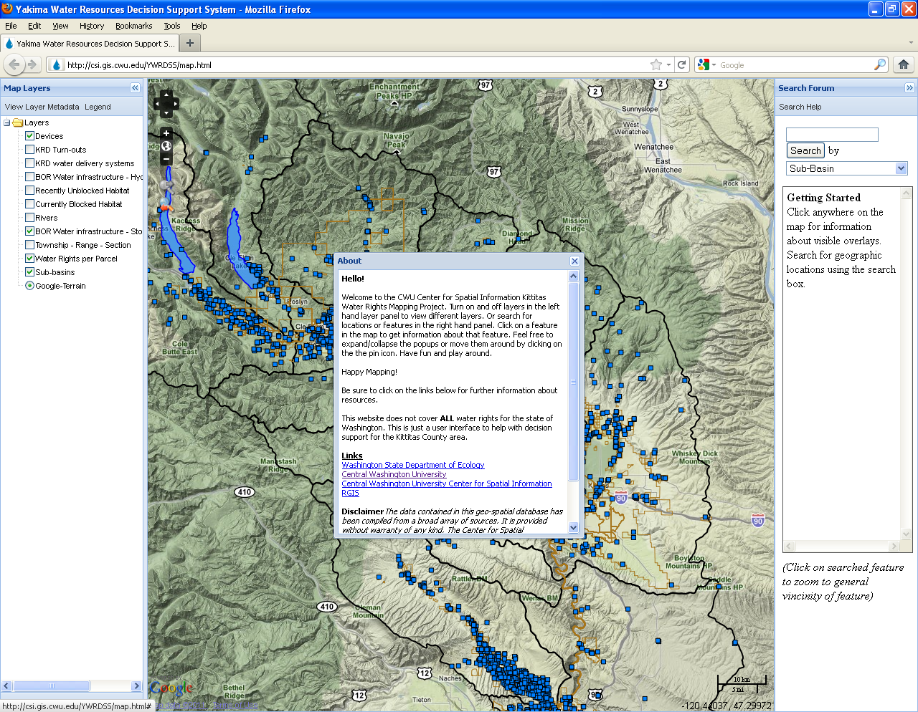

Figure 1: The Homepage for the Kittitas Valley WRDSS

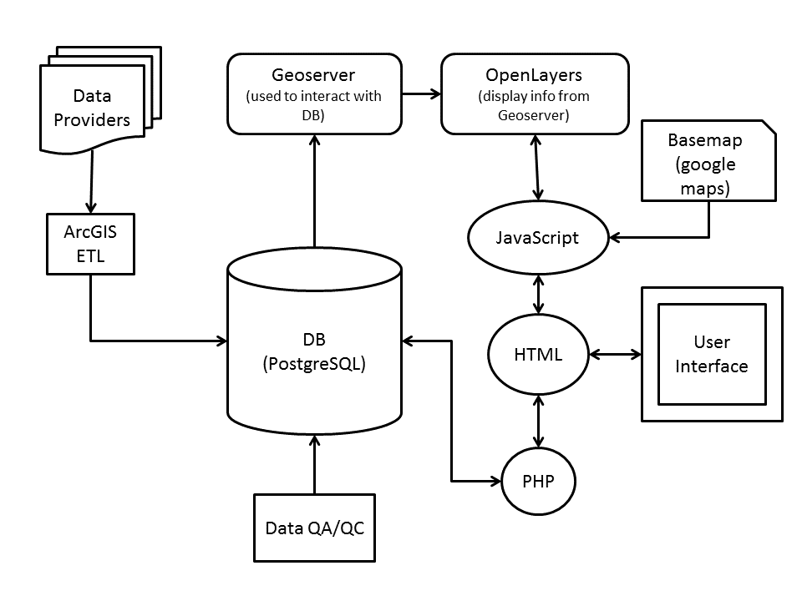Figure 2: Conceptual Diagram of the WRDSS

1. **THE DATABASE INFORMATION**

The database utilizes a series of pop-up windows to provide the user with additional information for individual items within the WRDSS. For example, Figure 3 shows a pop-up displaying information about a sub-basin, or sub-watershed within the WRDSS. Pop-ups are available for each data layer displayed in the left column. Each of these pop-ups contains metadata, explaining the source of the data and other key information about the data displayed. When looking at the interface users will see a view panel on each side of a large Google Map (Figure 3). In the left hand panel users have the options to turn on and off layers as well as click on buttons which launch javascript pop-up windows for layer metadata information, legend viewing, information about the site and layers. In the right hand panel users can search for features or attributes that they wish to view and the results of the search are displayed under the search forum. This queries the PostgreSQL database using PHP for any matching values that the user entered. Clicking on a search return will zoom the map to the feature.

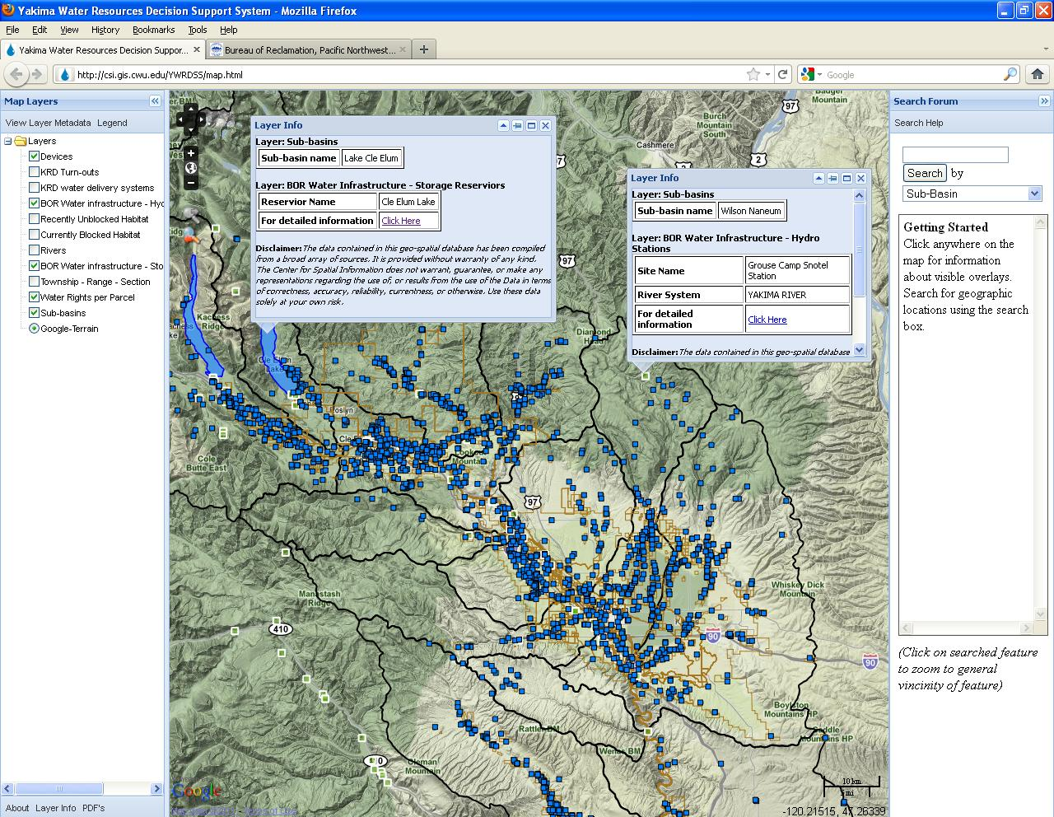

Figure 3: WRDSS geographic data displayed along with Pop-up windows displaying additional data and metadata for specific information

The center panel of the user interface contains the map displaying all the PostgreSQL data onto Google Maps through the use of OpenLayers and Geoserver. Users can pan, zoom, and click on a feature on the map. Clicking on a feature will open a pop-up window displaying all the information about the feature(s) the user selected (Figure 4). The pop-up information is produced by using built-in call functions in the OpenLayers java library. The function retrieves all the attributes and values from the PostgreSQL feature(s) and display that information in the pop-up.

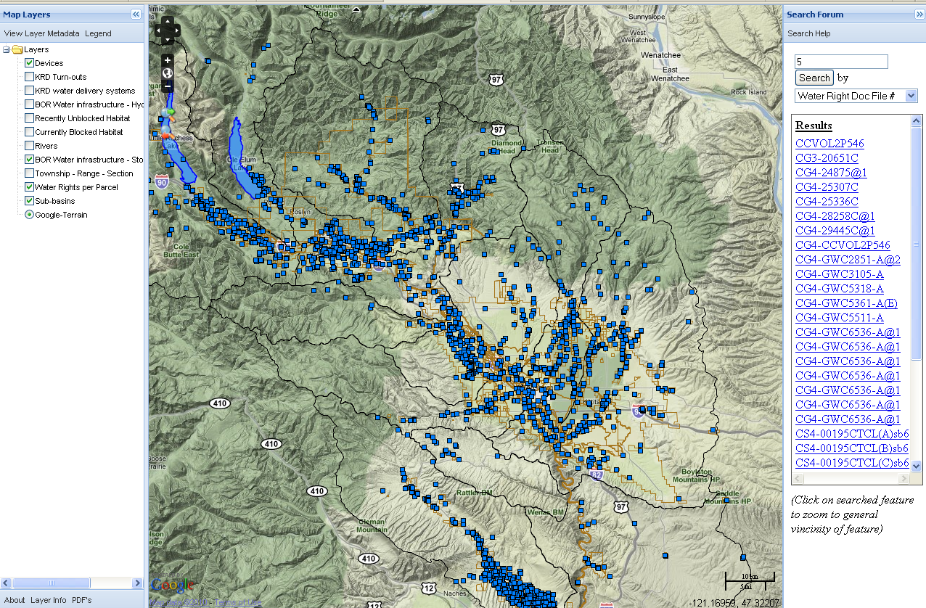  
Figure 4: Devices and Water Parcel data displayed within the WRDSS with Water Rights documents queried in the right column

The Water Rights data supplied originates from the conditional final decree in the Yakima River adjudication (Washington Department of Ecology, 2014a). These data are subject to change as the adjudication enters its final stages, but these data, as provided by the Washington Department of Ecology are the most accurate and up-to-date data available. If new data are made available, or if water rights are transferred, the database will be updated by its creator to reflect these changes using the Washington Department of Ecology’s Water Rights datasets. This requires technical support, which in this case is provided by an in-kind match from a grant. For other WRDSS upkeep will likely need to come from state water resource agencies. While this represents an additional cost, the benefit is a dynamic system, and one that can be accessed remotely, unlike the paper copies of water rights held in government offices—the ‘old’ style of accessing water rights data. Table 2 shows the data available by clicking on a given water rights parcel. This particular parcel was selected off of Manastash Creek, a tributary to the Yakima River in the Kittitas Valley. The data presented shows the purpose for which the water right was created (purpose), the Water right document number (Water Rights Doc ID), the legal file from which these data were accessed (Water Right Doc File Number), the state of the water right (Type), the verification method used by the Department of Ecology to ensure data accuracy of the water rights reported (Verification Method), the status of the document used to report the water right (Completion of Construction), the status of the water right (Status), the judicially-determined priority date of the water right (Priority), the quantity of water, in acre-feet, that can be applied to irrigate the land (Irrigation Acreage (ac-ft)), and the size, in acres, of the parcel that can be irrigated with this water right (Parcel Size (acres)).

Table 2: Sample Water Rights Parcel data

|  |  |
| --- | --- |
| **Purpose** | Irrigation |
| **Water Rights Doc ID** | 4292591 |
| **Water Right Doc File Number** | CS4-00477CTCL |
| **Type** | Change Application in the Permit stage |
| **Verification Method** | place-of-use mapped with good legal description and good spatial data features |
| **Doc Stage** | Completion of Construction |
| **Status** | Active |
| **Priority Date** | 09/18/2006 |
| **Irrigation Acreage (ac-ft)** | 1098.6 |
| **Parcel Size (acres)** | 156.36 |

For maximum utility a WRDSS should not just display spatial data but also link those data with analytical tools to enhance decision making (Mekonnen, 2014; Densham, 1991). In addition to allowing users to look at water rights, the WRDSS allows users to look at stream gages and reservoir levels, potentially allowing them to improve decisions about their water use based on current conditions. For example, a user can evaluate the current storage in any of the U.S. Bureau of Reclamation dams (Figure 5).

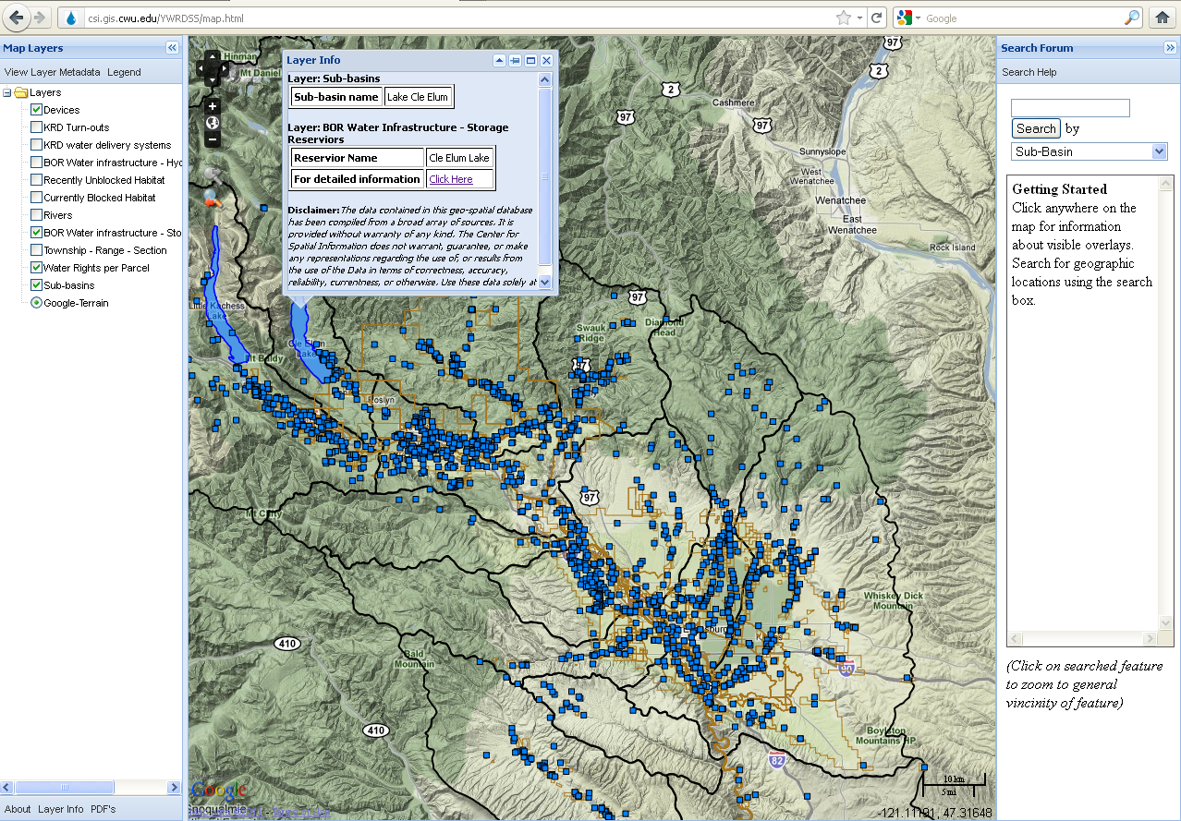Figure 5: The WRDSS with Lake Cle Elum selected. The user can then choose the provided hyperlink and be directed to the U.S. Bureau of Reclamations hydromet page on which current reservoir levels (mean surface level and volume of water stored (in acre-feet) are available.

1. **EXPANDING THE UTILITY**

**The development of the Yakima Basin WRDSS raises questions of how it can be expanded to increase its utility. Improvement and expansion of the dataset likely falls into two general categories: 1) additional data layers that can be added, and 2) identifying additional purposes or target audiences who could find this database useful. For example, Washington State’s Department of Ecology (2014b) created the early phases of an internet-based water bank for the Upper reach of the YRB entitled the Upper Kittitas Water Exchange. In 2014, the City of Ellensburg, Washington began a similar initiative (Johnston, 2014). Because of a moratorium on the issuance of groundwater permits (Washington Department of Ecology, 2011), these waterbanks are some of the few mechanisms by which homeowners can install a new well in portions of Kittitas County. Non-Governmental Organizations (NGOs) looking to obtain water for instream flows, or irrigators requiring additional water during periods of water scarcity can also use this tool for obtaining additional water supplies. Currently, the Department of Ecology’s water bank lacks spatial referencing, undermining its efficacy. A natural nexus could develop between a web-based WRDSS which could display this information graphically in a user-friendly format and the development of a properly functioning water bank.**

**At a later time, numerous land-use and hydrologic models, such as the draft U.S. Geological Survey’s Upper Kittitas Groundwater Model, could be integrated within the database providing water rights holders even more information. The WRDSS could also integrate habitat models such as Physical Habitat Simulation (PHABSIM) models (Milhous and Waddle, 2012) and System for Environmental Flow Analysis (SEFA, 2012). In areas like the YRB which are listed as Critical Habitat under the Endangered Species Act (1973) for federally listed salmon and bull trout (USFWS, 2014), these habitat models can be coupled with water rights data to identify areas requiring the establishment of instream flows, or areas in which NGOs might want to lease or purchase water to be left in the stream to improve habitat.**

1. **CONCLUSIONS**

Participatory GIS models are increasingly possible, powerful and integrative (Singh and Singh, 2014; Hoover, 2013; Singh et. al., 2012). The development of this WRDSS shows intricate legal data in the form of water rights can be displayed in a user-friendly manner. The increase in open-access datasets, and the ability to link these to better decision making tools (Densham, 1991) can provide resource managers and individual water rights holders’ better access to information. The created WRDSS for the Kittitas Valley demonstrates it is possible to display water rights data along with infrastructure, hydrologic, and other environmental data. This improved access to data could lead to better environmental management decisions. Perhaps no resource better exemplifies this than water rights; individual water entitlement holders can make informed decisions on how and where to use their water.

1. **REFERENCES**

Alagan, R. and Aladuwaka, S. (2013) Participatory Geographic Information Systems for Environmental Zoning Plan: Case Study of the Madu Ganga Estuary, Sri Lanka, in Barbara Wejnert (ed.) Voices of Globalization (Research in Political Sociology), 21, 217-232.

Arizona Department of Water Resources. (2014). Water Resource Data. Available at: <http://www.waterboards.ca.gov/waterrights/water_issues/programs/ewrims/>. Last Accessed, October, 2014.

Brookshire, D. and Coursey, D. (1987) Measuring the Value of a Public Good: An Empirical Comparison of Elicitation Procedures. *American Economic Review*, 77:4.

California Division of Water Rights. (2014) Electronic Water rights Information Management System. Available at: <http://www.waterboards.ca.gov/waterrights/water_issues/programs/ewrims/>. Last Revised, October, 8, 2014. Last Accessed, October, 2014.

Colorado Division of Water Resources. (2014) Map Search (AquaMap). Available at: <http://water.state.co.us/DataMaps/GISandMaps/AquaMap/Pages/default.aspx>. Last Accessed, October, 2014.

Corbett, J. and Keller, P. (2006) An Analytical Framework to Examine Empowerment Associated with Participatory Geographic Information Systems (PGIS). *Cartographica* 40(4): 91-102.

Densham, P. J. (1991) Spatial Decision Support Systems. *Geographical Information Systems: Principles and Application*, 1, 403-412.

Endangered Species Act. (1973) 16 U.S. Code §1531-1544.

**Gould, G.A. (1988)** Water Rights Transfers and Third-Party Effects. *Land and Water Law Review* (23): 1-41.

Hanak, E., Lund, J., Dinar, A., Gray, B., Howitt, R., Mount, J., Moyle, P., and Thompson, B. (2011) Managing California’s Water: From Conflict to Reconciliation(San Francisco: Public Policy Institute of California).

Hoover, J. (2013) Evaluating the Capacity for Internet GIS to Communicate Arsenic Groundwater Quality Information in the Four Corners, Southwest United States. Conference Proceedings, 2013 Annual Water Resources Conference, American Water Resources Association. November, 2013.

Idaho Department of Water Resources. (2014) General Mapping Tool. Available at: <http://maps.idwr.idaho.gov/mapall/>. Last Accessed, October, 2014.

Johnston, M. (2014) Land-Use Groups say Water Bank Issues Being Brought to Wrong Venue. *Daily Record News*. June, 6, 2014.

Krutilla, K. (2010) Transaction Costs and Environmental Policy: An Assessment  
 Framework and Literature Review, *International Review of Environmental and  
 Resource Economics*, 4, 261–354.

Mari, R., Bottai, L., Busillo, C., Calastrini, F., Gozzini, B., and Gualtieri, G. (2011) A GIS-based Interactive Web Decision Support System for Planning Wind Farms in Tuscany (Italy). *Renewable energy*, *36*(2), 754-763.

Matthews, O.P. (2003) Simplifying Western Water Rights to Facilitate Water Marketing, *Water Resources Update*,126, 40–44.

McCormick, Z. (1994) Institutional Barriers to Water Marketing in the West, *Water Resources Bulletin*, 30, 953–962.

Mekonnen, A. D. (2014) Wind Farm Site suitability Analysis in Lake Erie Using Web-Based Participatory GIS (PGIS). Doctoral Dissertation, Bowling Green State University.

Milhous, R.T. and Waddle, T.J. (2012) Physical Habitat Simulation (PHABSIM) Software for Windows (v.1.5.1). Fort Collins, CO: USGS Fort Collins Science Center.

Oregon Water Resources Department. (2014) Water Right Information Search. Available at: <http://www.oregon.gov/owrd/pages/WR/wris.aspx>. Last Accessed, October, 2014.

**Ottem, S.O. (2006) Quantifying Water Rights in General Stream Adjudications. *Journal of Contemporary Water Research and Education*. 133. 10-16.**

Parker, D., Cohen-Vogel, D.R., Osgood, D.E., and Zilberman, D. (2000) Publicly Funded Weather Database Benefits Users Statewide. *California Agriculture*. May, 21-25.

Pease, M. (2012) Water Transfer Laws and Policies: Tough Questions and

Institutional Reform for the Western United States, *Journal of Natural Resources Policy Research*, 4:2, 103-119

Schmidt, K.M., Menakis, J.P., Hardy, C.C., Hann, W.J., and Bunnell, D.L. (2002) Development of Coarse-Scale Spatial Data for Wildland Fire and Fuel Management. Gen. Tech. Rep.RMRS-GTR-87. Fort Collins, CO: U.S. Department of Agriculture, Forest Service, Rocky Mountain Research Station.

Singh, S.P. and Singh, P.S. (2014) Mapping Spatial Data on the Web Using Free and Open-Source Tools: A Prototype Implementation. *Journal of Geographic Information System*. 6:1, 30-39.

Singh, P.S., Chutiya, D., and Sudhakar, S. (2012) Development of a Web Based GIS Application for Spatial Natural Resources Information System Using Effective Open Source Software and Standards, *Journal of Geographic Information* *System*, 4:3, 261-266.

South Dakota Department of Environment and Natural Resources. (2014) Search for South Dakota Water Rights. Available at: <http://denr.sd.gov/des/wr/dbwrsearch.aspx>. Last Accessed, October, 2014.

State of Nevada Division of Water Resources. (2014) Permit Search. Available at: <http://water.nv.gov/data/permit/>. Last Accessed, October, 2014.

Streeter, D.H. (1988) Electronic Information—Public or Private Good? *Agribusiness*. 4:1, 39-48.

System for Environmental Flow Analysis (SEFA). (2012) Available at: <http://sefa.co.nz/> last accessed: July, 2014.

**UnitedStates Fish and Wildlife Service. (2014) Revised Draft Recovery Plan for the Coterminous United States Population of Bull Trout (*Salvelinus confluentus*). Portland, Oregon. 1-151.**

Utah Division of Water Rights. (2014) Searching Water Rights Records. Available at: <http://www.waterrights.utah.gov/wrinfo/query.asp>. Last Revised, March 26, 2014. Last Accessed, October, 2014.

**Washington Department of Ecology. (2014a) Water Rights Tracking System (WRATS). Available at:** <http://www.ecy.wa.gov/programs/wr/rights/tracking-apps.html>**, Last accessed, July, 2014.**

**Washington Department of Ecology. (2014b) Yakima Basin Water Exchanges. Available at:** <http://www.ecy.wa.gov/programs/wr/cro/wtrxchng.html>**, Last accessed, July, 2014.**

**Washington Department of Ecology. (2011) Upper Kittitas Ground Water Rule. Washington Administrative Code. 173-539A.**

Wyoming State engineer’s office. (2014) E-Permit System. Available at: <https://sites.google.com/a/wyo.gov/seo/>. Last accessed, October, 2014.

**Zambelli, P., Lora, C., Spinelli, R., Tattoni, C., Vitti, A., Zatelli, P., and Ciolli, M. (2012) A GIS Decision Support System for Regional Forest Management to Assess Biomass Availability for Renewable Energy Production. *Environmental Modelling and Software*, 38, 203-213.**

1. **Author info**
2. Funding for this project provided by ……omitted for review purposes
3. Available at: http://csi.gis.cwu.edu/YWRDSS/map.html